Communication  At Health Leadership High School, we believe that communication is what leads us to success!  Here are some of the ways we communicate with our students and families:  - https://healthleadershiphighschool.org  - Facebook: @healthleadershiphs  - Instagram: @healthabq  - Monthly Newsletter and important information sent via Remind App, email and Jupiter  - HLHS main line: 505-750-4547  - Title 1 Coordinator: Carolina Quinones-Suarez: 505-750-4547 x108 and via email at Carolina@healthleadershiphighschool.org  Student Support Resources:  https://sites.google.com/healthleadershiphighschool.org/socialwork/ | Health Leadership Family Engagement Policy 2020-21  Title I provides schools with additional funding to improve teaching and learning, so that all students have the same opportunity as other students to learn and meet today’s challenging grade level standards.  Families are welcome and encouraged to participate in the activities at HLHS, including how the Title I funds are spent.  Annual Meeting and SFEP Procedures  - HLHS will notify families’ when and how the Annual Meeting takes place with the purpose of reviewing and/or revising the District Family Engagement Support Agreement & the Title I District Family Engagement Process and Procedural Directive.  - The purpose of the SFEP Spring Meeting involves interested staff, students and regarding HLHS’s Engagement Policy.  - Information about the School’s 90 Day Plan is available at HLHS’s school office.  Volunteer Opportunities  Let families know how they can get involved.  - Are you looking for volunteers?  - Do you have a Parent Room?  - Does the school host special events for parents and families?  - Parent Conferences  - PTA or other organizations | The mission of Health Leadership High School is to equip students who are interested in health with the skills they need to become leaders in developing healthier communities. Through experimental and project based learning, our students develop as deep and complex thinkers to have a broad understanding of the determinants of improving healthier communities. Our mission is to take a holistic approach in supporting youth to have successful careers by caring for their intellectual, physical and emotional well-being as a student.  School Family Engagement Policy  2020-2021  Health Leadership high school  - Carolina Quinones-Suarez  - 505-750-4547 x108
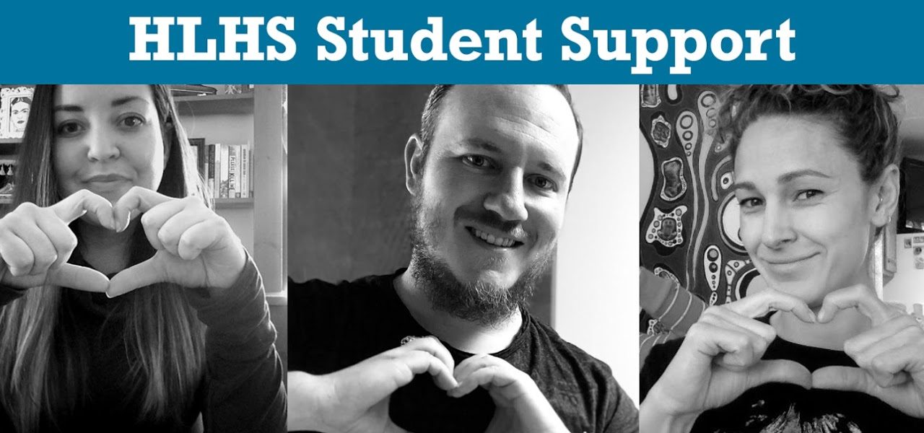  Transition Services  HLHS provides transition services that supports students educational journey at Health Leadership High School and beyond! Find out more information here:  Community Engagement Resources:  https://sites.google.com/healthleadershiphighschool.org/community-engagement-resources/home | Project Based Learning  Our project-based learning model fully integrates our pillars of community engagement and student support to create a learning environment that acknowledges each student’s needs and interests. All projects are supported by community partners who help students identify driving questions and real-world problems, and then act as mentors, collaborators, and audience for the student’s ongoing learning and project work | 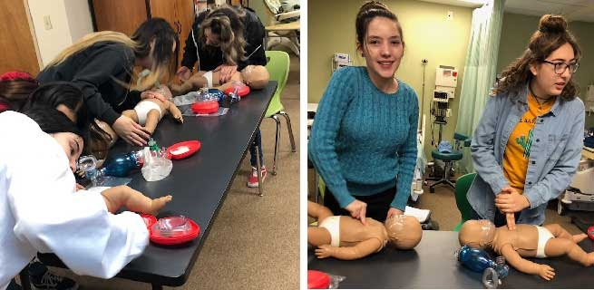  Health Leadership High School also has the first and only Community Health Workers Certification Program in the State of New Mexico!  HLHS offers dual credit classes in partnership with CNM, Nursing Assistant Certificate, Career and College Exploration and Access opportunities as well as paid and non-paid internships!  Health Leadership High School offers a day program and a Re-Engagement evening program for students ages 14-21!
.

