HEALTH LEADERSHIP HIGH SCHOOL FULL REENTRY: SY 2021/2022
COVID Safe Instructional Model
Who Will Participate in Full Reopening? All families have been surveyed in March to decide which of Health Leadership's two learning models is best for their family: 1) virtual, and 2) in person in the school building. Families that are comfortable in safely returning to school are welcome to. All families participating in on campus learning will participate in 1) an orientation, 2) review, commit & sign a COVID safe practices agreement, and 3) complete a COVID safe questionnaire each day prior to coming to the building.
Where are We at in the School Year? Health Leadership High School plans to fully reopen school on Monday April 5th, 2021. Health Leadership High School (HLHS) is in a two semester school year. The first semester took place from August to December 2020. We are in the middle of the second semester that began in January and ends in May. All HLHS students are on a two week Spring Break from Monday March 21st through Friday April 2nd, 2021. We will return after spring break on April 5, 2021.
What Does Learning Look Like? Students engage in learning through Student Support, Community Engage and Project-based learning. This looks like: Community responsive projects, Exhibitions (mini and full), Acellus, dual enrollment CNM courses, work based learning, paid internships and Senior Capstone. All programs will continue as slated; Health Occupations Students of America (HOSA), Grow our Own (GOO) Apprenticeship and practicum placements, Care Calls in collaboration with Aging and Long Term services, Volunteer opportunities with First Nations etc. Learning at Health Leadership High School is highly individualized based on student passions and need for support.
What is the Daily Schedule? Our daily schedule will remain the same as it has been since January and is listed on the next page.
***This brief overview is in addition to all statewide COVID safe policies, practices and protocols that Health Leadership High School is adhering to as evidenced by approval of full reopening by APS, NM PED & the Fire Marshall’s Office.
HEALTH LEADERSHIP HIGH SCHOOL FULL REOPENING:
APRIL & MAY 2021
2020 - 2021 RE-ENTRY SCHEDULE
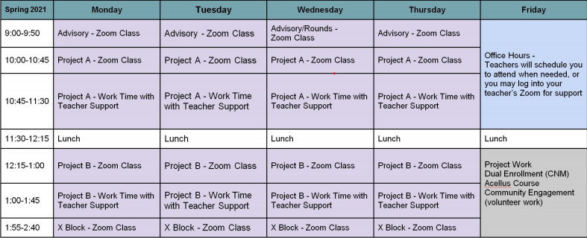
***This brief overview is in addition to all statewide COVID safe policies, practices and protocols that HLHS is adhering to as evidenced by approval of full reopening by APS, NM PED & the Fire Marshall’s Office.

